**Manual Testing Assignments**

1. What are the advantages of the agile process and explain the ceremonies in Agile?

Ans. Agile is the other name for flexibility. Hence the flexibility of agile model come with a set of special advantages and are as follows

* Increased Business Alignment

In agile model, the customers get to work closely with the development team. Hence it allows to align the business and IT division of the product.

* Focuses on business value

Agile methodology forces the product management team to make sure that, at any given point of time the development team focuses on the most valuable item to be delivered to the customers ensuring the customer satisfaction. This prioritizes the backlog item in the order of way they want to develop software product.

* Shorter delivery cycle

Agile model helps the customer to get return on investments as early as possible. Shorter delivery cycle helps the development team in getting the feedback which would help the team in deciding their next course of action.

* Improved Return of Investment (ROI)
* Improved visibility into product and progress

Agile model maintains transparency between both business and IT team as of how they are progressing towards the development of any given project

* Reduced cost of project

A lot of rework happens in agile model. We know that in all other models feedback is obtained at the end of the completion of work. But in case of Agile model feedback is obtained as every stage. Hence making the corrections and implementing those changes is easier which indirectly reduces the cost of the project.

* Faster development of new test ideas

New ideas may be tested easily and then the feedback may be obtained from the customer. Based on the customers feedback we may proceed or drop it .

* Continuous evaluation of the project

Agile model helps in obtaining the continuous evaluation from the end users making sure whether the end users are liking our product or not.

Ceremonies of Agile:

The **agile ceremonies list** includes:

1. Sprint Planning

The sprint planning ceremony sets teams up for success by ensuring everyone understand the sprint goals and how to achieve them.

During the sprint planning gets a clear idea about what the team should be able to accomplish at the end. This is known as a sprint goal.

1. Daily Stand-Up

Daily stand-up refers to daily meetings, where the progress of work, the work completed yesterday or the upcoming task are discussed.

1. Sprint Review

The Sprint Review is the time to showcase the team’s completed work and gather feedback from stakeholders.

1. Sprint Retrospective

In this final scrum ceremony in the sequence, we look back on the work we have just done and identify ways to do things better next time.

-------------------------------------------------------------------------------------------------------------

Q.no-2) What activities are performed in each phase of STLC? and How would you define that testing is sufficient and it’s time to enter the Test Closure phase?

Ans. STLC Model Phases

1. Requirement Analysis
2. Test Planning
3. Test case development
4. Test Environment setup
5. Test Execution
6. Test Cycle closure

**Requirement** **analysis:**

During this phase, feature requirements collected in the SDLC process are evaluated to identify testable aspects. If necessary, testing teams may need to consult with stakeholders to clarify requirements. These requirements may either be functional or non-functional.

**Test Planning:**

During this phase, the test strategy is outlined in a test plan document. This strategy includes tools needed, testing steps, and roles and responsibilities of each member of that team.

**Test case development:**

Test cases are written, which may have inputs, procedures, executing conditions etc. These test cases should be transparent, and efficient and must try to provide 100% coverage.

**Test Environment setup:**

A testing environment is a setup of software and hardware for the testing teams to execute test cases. In other words, it supports test execution with hardware, software and network configured. A test environment is configured as per the need of the application under test.

**Test Execution:**

During this phase, the test cases are executed. Then a comparison of actual and expected results is made. If the actual and expected result is the same, then the test case said to be passed.

**Test completion criteria**

A test is said to be complete if the following criteria is satisfied:

* Sufficient coverage is provided by test cases.
* All test cases planned for the phase have been executed.
* All high-priority bugs are fixed and verified.
* High-risk areas are addressed and properly tested.
* Acceptance testing is passed.

If the above conditions are satisfied, then it’s time to close the test execution and testers proceed to the closure phase.

Q.no-3) Explain different types of testing and sub Categories in detail with an example?

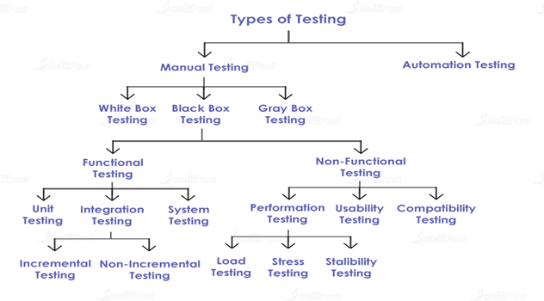

Ans: Types of testing are classified majorly into 2 types:

* Manual Testing
* Automatic Testing

Manual testing are further classified as:

* White Box Testing

White-box testing or glass-box testing is a software testing technique that tests the software by using the knowledge of internal data structures, physical logic flow, and architecture at the level of source code.

* Black Box Testing

Black box testing is a type of software testing in which the functionality of the software is not known. The testing is done without internal knowledge of the product. This is further classified into:

1. Functional testing: Testing of those aspects which affects the functionality of the software. In other words, it is the type of testing where it is found whether each functional aspect of software is working as per the software requirement.

**Types of functional testing:**

* Unit testing: Before testing whether the entire software is working , make sure that the individual parts work properly on their own. Unit testing is done by developers.
* Integration testing: Integration testing is a software testing technique that focuses on verifying the interactions and data exchange between different components or modules of a software application
* System Testing: This is the testing of completely integrated software product.to verify that it meets the software requirements.

1. Non-Functional testing: Testing of those aspects which doesn’t affects the functionality of the software.

**Types of Non-Functional Testing**

* Performance Testing: **This is the type of** software testing process used for testing the speed, response time, stability, scalability, and resource usage of a software application under a particular workload.
* Usability Testing: Type of testing for measuring how easy and user-friendly a software application is.
* Compatibility Testing: Type of testing to check whether your software is capable of running on different hardware, operating systems.
* Gray Box Testing

Gray Box Testing is a combination of the Black Box Testing technique and the White Box Testing technique in software testing. This is also called user acceptance testing.

**Types of Performance testing are follows**

* Load testing: [Load testing](http://searchsoftwarequality.techtarget.com/definition/load-testing) measures system performance as the workload increases. That workload could mean concurrent users or transactions.
* Stress Testing: Also known as fatigue testing is meant to measure system performance outside of the parameters of normal working conditions.
* Stability Testing: **This is the** type of testing performed to measure efficiency and ability of a software application to continuously function over a long period of time.

Q.No 4) Prepare the test cases for the below scenario

Scenario 1: Verify that 'About Us' link should be displayed in footer and User should be able to click on 'About Us' link. Application URL: <https://www.olacabs.com/>

Ans. Written in the Excel sheet format

Q.No 5) In Flipkart website when user click on the Cart option System is not responding, Raise the Jira defect and assign and complete the below task:

1. Provide Title of the bug

2. Description

3. Steps to Reproduce

4. Actual Result

5. Expected Result

Ans. The steps for the raising the JIRA defect are as follows:

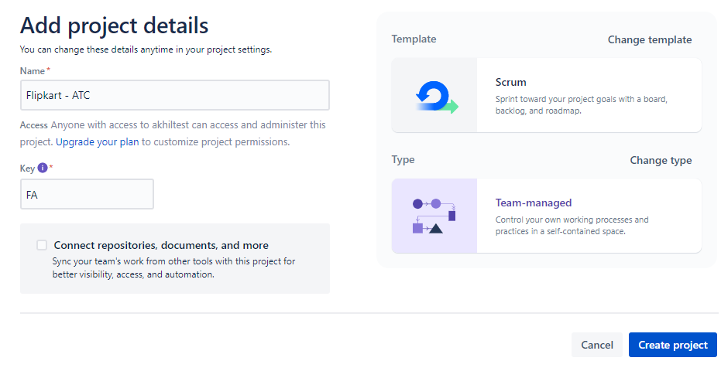

Step 1. Create a project and give a name of your choice

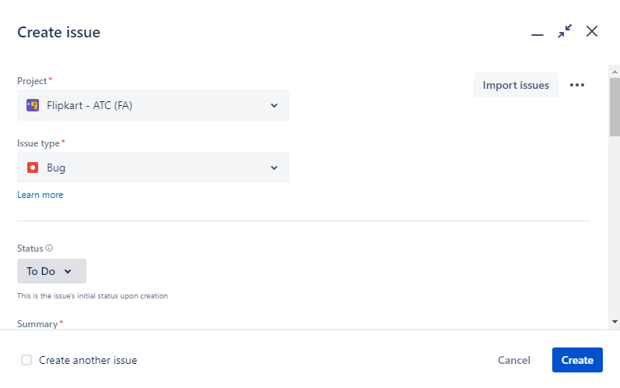

Step.2 - Click on the create option from task bar and select the options as requires. Since we need to create a bug , we have selected Issue Type as “Bug” . Similary the status is kept as to do.

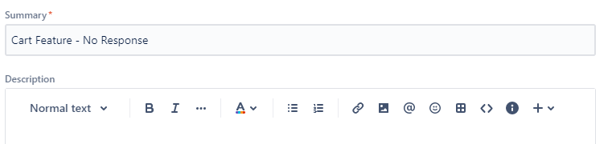

Step.3 - Give a summary of the bug that we need to create . In our case it is **“Cart feature – No response ”.**

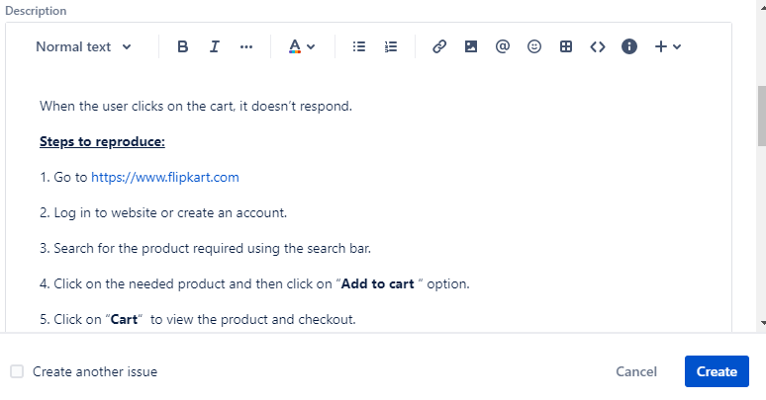

Step.4 ) Write the description of the project describing the issue. Along with that also mention Steps to reproduce .



Step 5 . ) Write the expected and actual result .

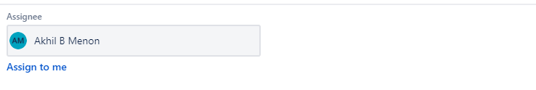

Step.6 ) Select the person to whom the bug needs to be assigned.